COSC 290.002

Class Exercise #7

1. Tyrone Shoelaces has invested a huge amount of money into the stock market and doesn’t trust just anyone to give him buying and selling information. Before he will buy a certain stock, he must get input from three sources. His first source is Pain Webster, a famous stockbroker. His second source is Meg A. Cash, a self-made millionaire in the stock market, and his third source is Madame LaZora, world-famous psychic. After several months of receiving advice from all three, he has come to the following conclusions:

a. Buy if Pain and Meg both say Yes and the psychic says No.

b. Buy if the psychic says Yes.

c. Don’t buy otherwise

Construct a truth table and find the minimized Boolean function to implement the logic telling Tyrone when to buy.

|  |  |  |  |
| --- | --- | --- | --- |
| Pain (x) | Meg (y) | Psychic (z) | Buy? (F(x,y,z)) |
| 0 | 0 | 0 | 0 |
| 0 | 0 | 1 | 1 |
| 0 | 1 | 0 | 0 |
| 0 | 1 | 1 | 1 |
| 1 | 0 | 0 | 0 |
| 1 | 0 | 1 | 1 |
| 1 | 1 | 0 | 1 |
| 1 | 1 | 1 | 1 |

F(x,y,z) = z + xy

2. Analyze the following sequential circuit by determining the truth table. (Complete Output and Next State columns in the truth table.)



|  |  |  |  |  |
| --- | --- | --- | --- | --- |
| Present State  Z(Q(t)) | Inputs  X Y | Output  S | Next State  Q(t+1) | Not sure how to notate Q(t+1), so I wrote what the table says it equals, then also wrote the discrete value it has at that point |
| 0 | 0 0 | 0 | Q(t) -> 0 |  |
| 0 | 0 1 | 1 | Q(t) -> 0 |  |
| 0 | 1 0 | 1 | Q(t) -> 0 |  |
| 0 | 1 1 | 1 | Q’(t) -> 1 | Wouldn’t Q’(t) = 1 also change S to 1 since the full adder isn’t on a clock? |
| 1 | 0 0 | 1 | Q(t) -> 1 |  |
| 1 | 0 1 | 1 | Q’(t) -> 0 | Wouldn’t Q’(t) = 0 also change S to 1 since the full adder isn’t on a clock? |
| 1 | 1 0 | 1 | Q’(t) -> 0 | Wouldn’t Q’(t) = 0 also change S to 1 since the full adder isn’t on a clock? |
| 1 | 1 1 | 0 | Q’(t) -> 0 | Wouldn’t Q’(t) = 0 also change S to 0 since the full adder isn’t on a clock? |

(Hint: J-K flip-flop characteristic table is as follows:

|  |  |
| --- | --- |
| J K | Q(t+1) |
| 0 0 | Q(t) |
| 0 1 | 0 |
| 1 0 | 1 |
| 1 1 | Q**’**(t) |

1. Analyze the following sequential circuit by determining the table when Count Enable input is 1. (Complete Next State columns in the table.)

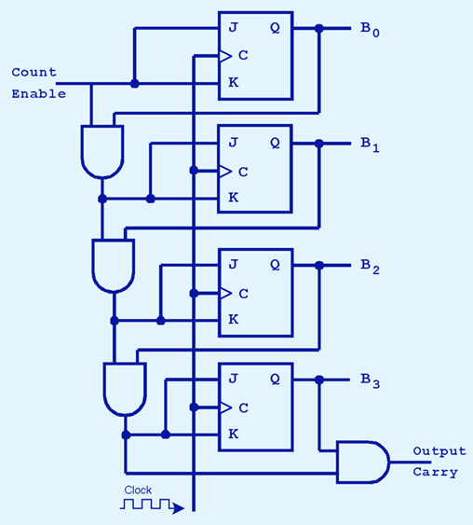

|  |  |
| --- | --- |
| Present State Q(t)  B0 B1 B2 B3 | Next State Q(t+1)  B0 B1 B2 B3 OutputCarry |
| 0 0 0 0 | 1 0 0 0 0 |
| 0 0 0 1 | 1 0 0 1 0 |
| 0 0 1 1 | 1 0 1 1 0 |
| 0 1 0 1 | 1 1 0 1 0 |
| 1 0 0 0 | 0 1 0 0 0 |
| 1 0 0 1 | 0 1 0 1 0 |
| 1 0 1 0 | 0 1 1 0 0 |
| 1 1 1 1 | 0 0 0 0 0 |